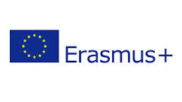

ERASMUS+ PROGRAMM FOR TEACHING EXCHANGE (STA) 2021/2022

LETTER OF INVITATION

UNIVERSITY OF CÓRDOBA
ERASMUS code: E CORDOBA01

I hereby confirm the invitation to Mr./Ms. (full name of the invited person) specialist in (information of the specialization field of the invited person), worker of the (invited’s company name) (Country of the company) for a teaching exchange within the framework of the Erasmus Teaching Staff Mobility Programme (STA), in the academic year 2020/2021 in the field of _____________________________________on our studies of: (name of the Degree/Master in UCO)

Degree

Master

The costs for this STA Erasmus+ exchange will be covered according to calling published by UCO on November the 29th, 2021 (BOUCO).

I also confirm that I am entitled to issue this declaration.

(Name of the UCO teacher who issue and sign this invitation)
(Position of the UCO teacher who issue and sign this invitation)

Signature

Place and date

