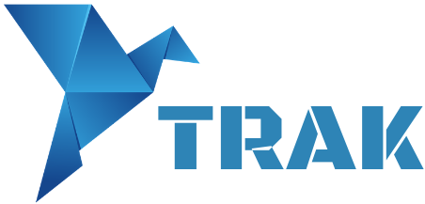
Symposium Translation and Knowledge Transfer:
News trends in the theory and practice of translation and interpreting
Universidad de Córdoba (Spain), 17-18 October 2019

Abstracts should be sent to:
Mar Ogea-Pozo (lr1ogpom@uco.es); Carmen Expósito-Castro (lr1excac@uco.es)

AUTHOR(S):
AFFILIATION:
E -MAIL:
Phone number:

TITLE

Abstract (300 words)
Keywords (5 words)
References (5 maximum)

BIODATA (150 words)

