THIRD INTERNATIONAL CONFERENCE ON ACETIC ACID BACTERIA. VINEGAR AND OTHER PRODUCTS.
April, 17-20
Córdoba, SPAIN

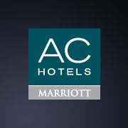 | AC HOTEL CÓRDOBA PALACIO (5*)  Paseo de la Victoria, S/N  14004 Córdoba, SPAIN  Phone: +34 957 760 452  Fax: +34 957 760 456  acforum.accordobapalacio@ac-hotels.com  www.ac-hotels.com

RESERVATION FORM
Title:
First name:
Last name:
Address:
City:
Country:
Email address:
Telephone:
Check-in date:
Check-out date:
Number of Rooms:
Guests per room:
Comments:

- Please, send this form by either email (acforum.accordobapalacio@ac-hotels.com) or fax (+34 957 760 456).
- For confirmation and guarantee conditions, the Hotel will contact you as soon as possible.

