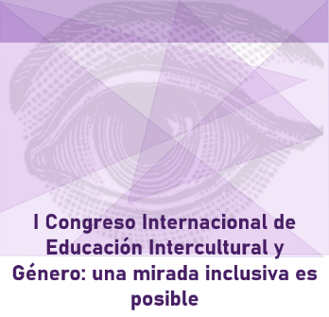
REGISTRATION FORM

I Congreso Internacional de Educación intercultural y género: una mirada inclusiva es posible

30 y 31 de octubre de 2019

PERSONAL INFORMATION

NAME: | Please enter your full name
I.D. CARD / PASSPORT: | Please enter your ID Card or Passport
COUNTRY:  Please enter your country | CITY:  Please enter your city | STATE/COUNTY:  Please enter your state/county
PHONE:  Please enter your phone | EMAIL:  Please enter your email
Please indicate your modality of participation in the Conference:

Please indicate Attendee or Participant with communication

I will attend the cultural activity: Alma de Córdoba – Night visit to the Mosque-Cathedral in Cordoba that will be held on Wednesday evening, October 30:

Please indicate Yes or No

I will attend the cocktail that will be held on Wednesday evening, October 30:

Please indicate Yes or No

*Once the registration form has been completed, please send it and the abstract of the proposal for communication to the following email: catedraintercultural@uco.es

