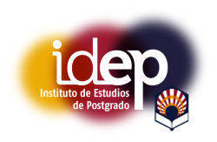

REPORT OF THE MEMBER OF THE PhD COMMISSION after the exposition and defense of the Thesis (art. 2 del RD 534/2013 y artículo 33.c de la Normativa de la UCO adaptada al RD 99/2011)

Professor:

Identity Document:

Member of the Commission of the thesis of :

Evaluation of the Doctoral Thesis and training activities report:

Mark *:

Córdoba, ...... of ........................... of .............

Signature:.....................................

* art. 2 del RD 534/2013 The Commission will present a report and the overall mark for the Thesis according to the following scores: no apto, aprobado, notable, sobresaliente.

